1-How can we add 2 bits?

a) Using a Half Adder (HA) b) Using a Full ADDER c)Both d)Non e)?

2- How can we add 3 bits?

a) Using a Half Adder (HA) b)Using a Full ADDER c)Both d)Non e)?

3- What this schema represents?

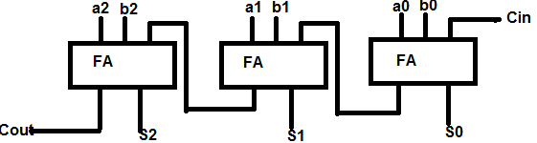

a) A Ripple Adder b) Carry look ahead adder c) Carry Save Adder d) Carry select adder

4- What is the function of this system?

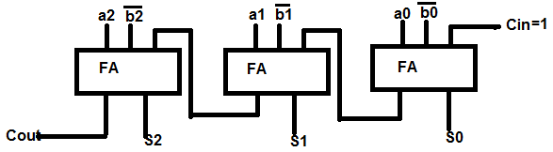

a) A+B b) A-B c) A+B+! d) A-B-1 e)?

5- What is the function of this system?

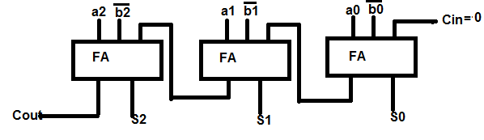

a) A+B b) A-B c) A+B+! d) A-B-1 e)?

6- What is the function of this system?

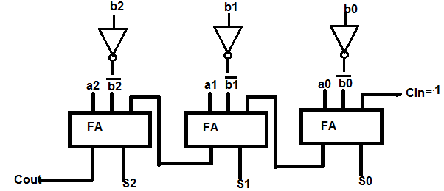

a) A+B b) A-B c) A+B+! d) A-B-1 e)?

7-What is the advantage of circuit (X) over circuit (Y)?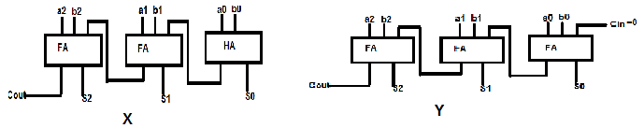

a)Speed b) Chip Area c)Power dissipation d) Nothing e)?

8-What is the advantage of circuit (y) over circuit (X)?

a)Speed b) Chip Area c) Regularity d) Possibility of cascading e)?

9- Using Multiplexer (MUX) which one (s) is (are) realizable?

a)AND2 b) NOR3 c) XOR2 d) XOR4

10-Which one is a Universal (Complete) Gate?

a) AND b) NOR c) XOR d) XNOR